From: [luans@oregonstate.edu](mailto:luans@oregonstate.edu)

To: [schauera@oregonstate.edu](mailto:schauera@oregonstate.edu)

Subject: Job Organization Culture Report

Date: 2014-04-21

|  |  |
| --- | --- |
| Red Hat Inc. |  |
| 100 East Davie Street, Raleigh, North Carolina 27601 | Phone: 1-919-754-3700 | Fax: 1-919-754-3701  Website: <http://www.redhat.com> | |

This is my specific report on the employment opportunity from Red Hat Inc. as a system programmer. In addition, I contacted a Red Hat Inc. human resource staff member, Pamela Burke, to obtain further information about the position that was not available in the job posting or company website.

POSITION: Senior Software Engineer

*Summary of Duties*

The summary of duties as outlined on the job posting:

* Act as an Open Shift expert focused on the standardization of containers, which will include work around Docker and Kubernetes, within the Open Shift by Red Hat and Red Hat Atomic environments
* Determine the most effective frameworks to focus on
* Integrate the right ecosystem of modules needed to complete the developer experience
* Communicate with multiple teams within Red Hat, as well as with the open source community
* Help understand and prioritize requirement decisions
* Contribute to Open Shift to deliver needed functionality

*Work Environment*

The purpose of this position is that the Red Hat Open Shift team is looking for a Senior Software Engineer to join us in Mountain View, CA. In this role, you will help your team build a service that will change how development is done using Red Hat's leading technologies and services hosted in the cloud. We'll need you to be excited to work in a fast-paced and sometimes chaotic environment with the goal of making our end users and customers more effective with every release.

Senior software engineer will work in an individual workspace with his or her team. Every employee has an individual workspace with equipping a desktop. Therefore, you do not have to take a personal laptop to do every day works. Every software programmer is required to work hard and create more creative software always. Technique and security is basic principle for each software developer. Senior software engineer is asked to communicate with each member in his or her team for actual development of software. Software engineers must spend most their time to work in the individual workspace, do not do some irrelevant thing during working time. They should be prepared for works and daily plans before office hour.

*Desirable Applicant Skills*

* Master's degree in computer science
* Excellent written and verbal English language skills for communicating with other open source community members, Open Shift engineers, product managers, and management across the globe
* Experience with or the ability to learn the following technologies:
  + Red Hat Enterprise Linux (RHEL) and Fedora
  + Docker and Kubernetes
  + Open Shift
  + Open Shift end users
  + Variants of Open Shift providing environments for Java, Red Hat JBoss Middleware, Node.js, Ruby, PHP, Python, Perl and others, as well as database environments such as MySQL, MongoDB, and Post Gres
* Familiarity with the following and expert-level knowledge of at least one:
  + Large scale LAMP architectures and deployment techniques
  + Upstream communities
  + Ruby and Bash scripting

*Required Education*

“A bachelor or master degree in Computer Science with a two-year experience at least.” (Red Hat Inc., 2016) is desired. Engineers must be able to understand and design reasonable software architecture, and then can write code during development.  In order to preform development duties, engineers need to communicate and type documents about scheme for software projects. Applicants are not required to obtain any special licenses or certificates. Red Hat is proud to be an equal opportunity workplace and an affirmative action employer. “We review applications for employment without regard to their race, color, religion, sex, sexual orientation, gender identity, national origin, ancestry, citizenship, age, uniformed services, genetic information, physical or mental disability, medical condition, marital status, or any other basis prohibited by law.” (Red Hat Inc., 2016)

*Salary and Benefits*

This is a per year position at $60,000 to $85,000. Senior software engineers work a standard and full 40-hour work week, Monday through Friday (Red Hat Inc., 2016). Sometimes, responding customers’ requirements, engineers have to work over time to debug and improve functional code overtime. Software engineers develop qualified software products compatible to Red Hat Linux Operating System. “Red Hat's benefits package is medical, dental and 401 are pretty good. PTO is good also but need to use PTO days during company shut down at the end of the year.” (Red Hat Inc, 2015)

*Location*

This laboratory position is located in Mountain View, California, which is It is named for its views of the Santa Cruz Mountains. From its origins as a stagecoach stop, it grew to a large suburb with a pedestrian-friendly downtown, free Wi-Fi, and a population of 74,066. The city borders Palo Alto and the San Francisco Bay to the north and Los Altos and Moffett Federal Airfield and Sunnyvale to the south. Many employees choose to live nearby here that is 25 miles north because renting price is a little cheaper.

**EMPLOYER**

This part of the report will provide background in the Employer.

Red Hat, Inc. was an American multinational software company providing open-source software products to the enterprise community. It was founded in 1993. Red Hat Inc. is a provider of open source software solutions to the enterprises. “The company's core offerings include Red Hat Enterprise Linux, Red Hat Enterprise Virtualization, Red Hat JBoss Middleware, Red Hat Storage Technologies, Red Hat Cloud Infrastructure and Open Shift by Red Hat, among others.” (Red Hat Inc. 2015) The company operates primarily in the Americas. It is headquartered in Raleigh, North Carolina, with satellite offices worldwide and employed 7,300 people as of February 28, 2015.

The company recorded revenues of $1,789.5 million during the financial year ended February 2015 (FY2015), an increase of 16.6% over FY2014.The operating profit of the company was $250 million in FY2015, an increase of 7.6% over FY2014. The net profit of the company was $180.2 million in FY2015, an increase of 1.1% over FY2014.

On the company’s official website, Red Hat Inc. says that it strives “More than 2 decades ago, Red Hat had a spark of an idea—a vision for developing software differently. We believed that collaboration with an ecosystem of IT leaders, open source advocates, developers, and partners could create a better foundation for the future of IT—Red Hat® Enterprise Linux®. But that was just the beginning. Today, we deliver a comprehensive portfolio of secure products and services using the same open, collaborative business model and an affordable, predictable subscription model.” (Red Hat Inc, 2015)

The Red Hat Inc. project achievements, as stated on the website is “Red Hat is investing in 3 strategic areas: platforms (such as Red Hat Enterprise Linux and Red Hat OpenStack Platform), middleware/PaaS (such as Red Hat JBoss Middleware, Fuse, and Open Shift), and management (such as Red Hat Cloud Forms and identity management).” (Red Hat Inc, 2015) According to two independent employee reviews posted on its official website, Red Hat Inc. holds true to their mission and values.

Key Personnel Red hat Inc. is a publicly traded company, governed by President, Jeff Feeler, and the board of directors. Board of Directors: Lincoln Baxter, Torvald Riegel, and Lincoln Baxter. The Mountain View location site manager is Werner Knoblich, who is also a senior vice president and general manager. Senior software engineer will report to the senior software engineer, Lincoln Baxter.

*Conclusion*

For an applicant who is comfortable working in a laboratory, and enjoys living in rural Idaho, this job could be very satisfying. Red Hat Inc. seems to be good employer offering competitive salary and benefits for the local Mountain View economy. Due to the lack of employment opportunities in the area for an undergraduate studying Computer Science, this position would be an excellent job opportunity to improve individual skills and abilities, also realize value of personal life. To submit an application, go to www.redhat.com, click on job@RedHat in tope right hand corner and follow prompts. Applicants will be interviewed on site. (SWOT Analysis, 2015)

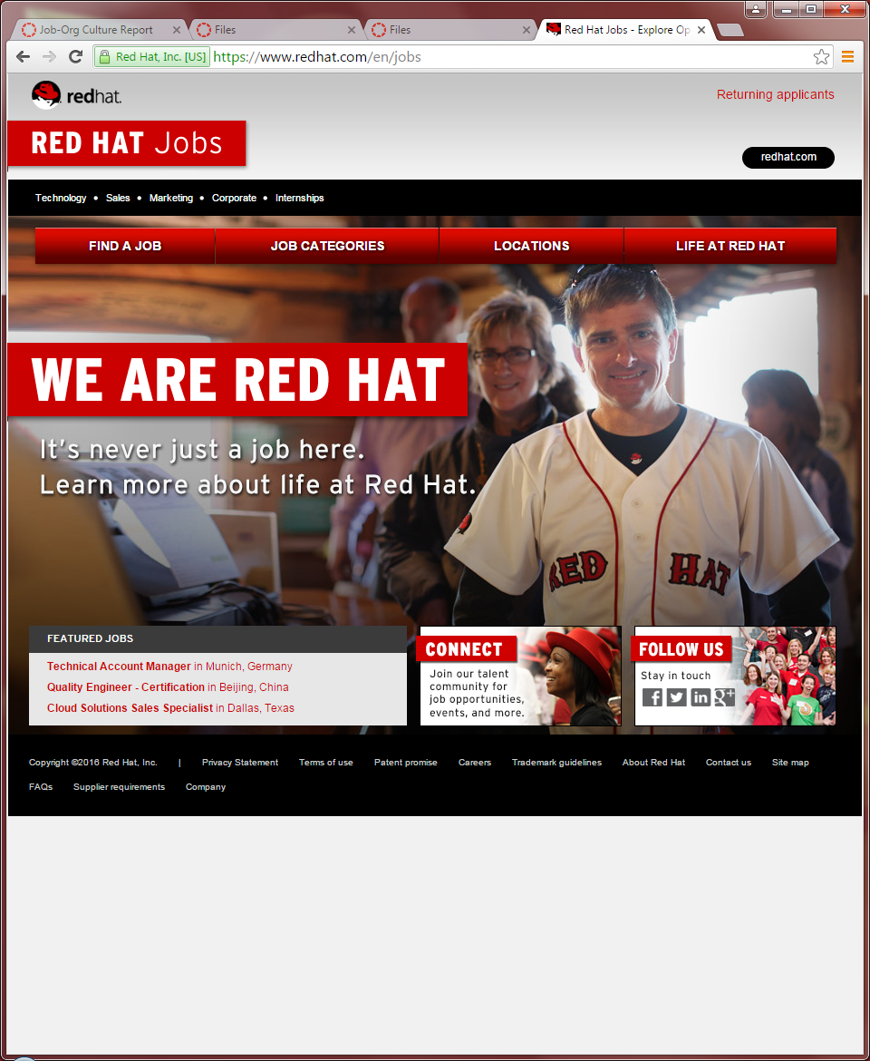

Red Hat Inc. (2016). Senior Software Engineer. Boise: Red Hat Engineer. Retrieved on April 8, 2016 from: <https://careers-redhat.icims.com/jobs/50929/senior-software-engineer/job>

Red Hat Inc. (2015). COMPANY INFORMATION We are Red Hat, enterprise IT solutions. Retrieved on 2015 from: <https://www.redhat.com/en/about/company>

Red Hat, Inc. SWOT Analysis. Oregon State University Library Database. Retrieved on May 1, 2015 from: <http://web.b.ebscohost.com.ezproxy.proxy.library.oregonstate.edu/ehost/pdfviewer/pdfviewer?sid=36a58ced-9c56-4622-9e8c-4f5e01d896bd%40sessionmgr114&vid=0&hid=109>